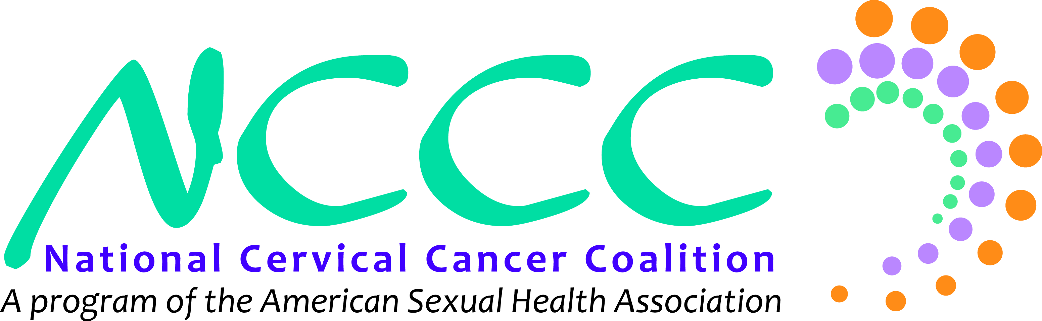

**How to get food, gift cards, and other materials donated FOR FREE!**

Below there is a letter that you can take into most restaurants and other businesses to request that they donate materials to your event and cause, with the understanding that the value of the donation can be written off of their businesses taxes as a charitable donation.

Here are some best practices for using this donation letter:

1. When you go to the store, ask to speak to the manager about a “charitable donation”
2. Personalize it – be sure to put the name of the company and sign your name
3. Include information about your local chapter, why you formed, what you have or hope to accomplish
4. Put your information so they can get back in touch with you !
5. Many big corporations (Walmart, grocery chains, restaurant chains) have policies for this in place, where the manager is allowed to donate a certain amount each month, so they can usually donate on the spot and you don’t need to come back
6. For the corporations that have these policies in place, it can be best to visit the location at the start of the month because managers will sometimes claim to have used all their money by the end of the month.
7. Plan to visit multiple locations because not every location will be willing/able to donate and each location is usually only willing to donate less than $50 per event/organization
8. YES! If your town has two Walmart locations – visit them both!
9. While small businesses may not already have this policy in place or experience with doing this, it is still very useful to ask them because they often tend to be more invested in the community and therefore more generous with their giving!



<<Date>>

To the attention of the Manager:

Greetings,

The National Cervical Cancer Coalition is hosting an event. <<Here give some information about your event, what it is, when and where, and why it is beneficial and important to the community>>.

I have visited you today to ask that <<Company Name>> please donate <<what you want, $30 gift card, soda, chips, typically expect ~$20-30 per location, so plan to solicit a few locations>>.

These items will <<what are they going to be used for?>>.

Donations to the National Cervical Cancer Coalition, a program of the American Sexual Health Association are tax deductible and our Federal Tax ID is 94-2494435. The National Cervical Cancer Coalition is a non-partisan organization that does not endorse or give a platform to electoral candidates.

Sincerely,

<<Your name>>

<<Your email>>

<<Your number>>